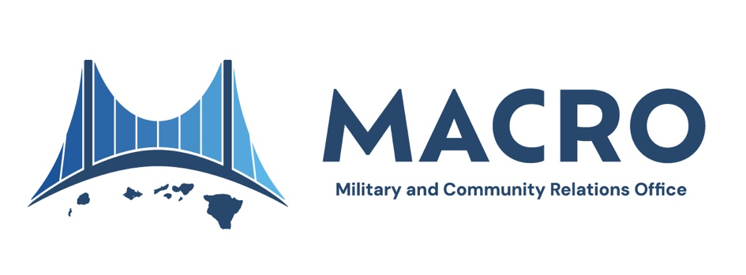

**Military History and Presence in Hawai‘i**

The relationship between the military and Hawai‘i spans centuries, shaped by the islands’ central location in the Pacific and their unique cultural and geopolitical significance.

As early as the 1820s, U.S. Navy ships visited Hawai‘i for resupply and repairs, recognizing the islands’ important position in the Pacific. By 1843, treaties between the U.S. and the Hawaiian Kingdom allowed American ships access to Hawaiian harbors, fostering early connections between the two nations.

During the 1850s, the Hawaiian Kingdom entered into agreements with the United States to support trade and maritime activity, enhancing its role as a Pacific hub. These relationships later influenced Hawai‘i's transformation into a U.S. territory in 1898, with Pearl Harbor emerging as a key maritime base.

**World War II and its Aftermath**

Hawai‘i’s role in history became more prominent after the events of December 7, 1941, when Pearl Harbor was attacked. This tragic moment catalyzed the United States’ entry into World War II and underscored Hawai‘i's strategic significance. In the years that followed, Hawai‘i served as a critical command center for operations in the Pacific, contributing to efforts aimed at maintaining peace and security across the region.

**Cold War and Present-Day Presence**

Post-WWII, Hawai‘i became central to U.S. efforts during the Cold War, housing important military installations. Today, these facilities play a dual role in safeguarding regional stability and contributing to Hawai‘i's economy. Currently, more than 146,000 military members and their dependents call the state home as do approximately 20,000 defense civilians, 115,000 veterans, and 18,000 military retirees. Around 221,000 acres of land, or 5% of the state’s total area, are used by the military. This presence includes key locations such as Pearl Harbor-Hickam, Marine Corps Base Hawaii, Schofield Barracks, and Fort Shafter.

**A Shared Responsibility**

Military activity in Hawai‘i remains an integral part of the U.S. Indo-Pacific strategy, with the state hosting the U.S. Indo-Pacific Command (INDOPACOM), as well as the Component Commands of Army, Marine Corps, Navy, Air Force, Space Force, 14th Coast Guard District and our own National Guard. Each of these military maintain peace and security in the region and deter potential enemies. Hawai‘i's role goes beyond military operations, fostering collaborative partnerships that emphasize environmental stewardship, economic resilience, and cultural respect.

While military history has shaped Hawai‘i’s modern identity, there remains an ongoing effort to balance strategic priorities with a commitment to honoring the state’s unique cultural and environmental heritage.