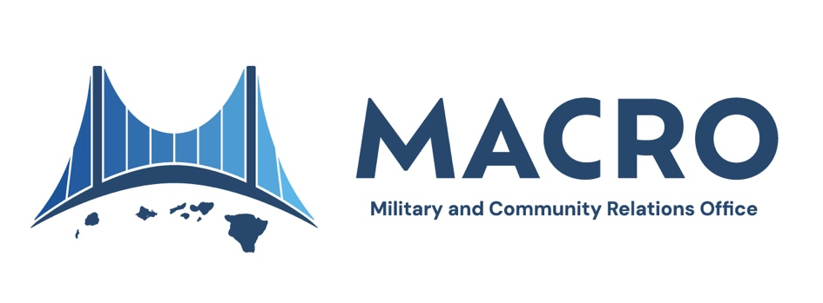

**Fact Sheet**

**DESCRIPTION:**  The Military and Community Relations Office (MACRO) was established

on April 1, 2024, under the Department of Business, Economic Development, and Tourism (DBEDT) to strengthen connections between Hawai‘i’s military and civilian sectors. Funded through a grant from the Office of Local Defense Community Cooperation, MACRO is dedicated to addressing issues that matter to both the State of Hawai‘i and the U.S. Department of Defense (DOD), ensuring collaboration that benefits Hawai‘i’s people, environment, and economy.

**MISSION:** To promote positive relationships between Hawai‘i’s military and civilian sectors by fostering mutual respect and understanding through collaboration on issues important to both the United States Department of Defense and the State of Hawai‘i. Through engagement, education, and transparent communication with the military, MACRO is committed to promoting and preserving the cultural, economic, and environmental foundations of Hawai‘i.

**VISION:** To build a sustainable future for Hawai‘i by strengthening bonds between the U.S. Department of Defense and the State of Hawai‘i, promoting cooperation and shared benefits across military and civilian communities.

**AREAS OF**

**COLLABORATION:** MACRO’s work centers on fostering collaboration between Hawai‘i’s military and civilian sectors across several key areas:

Environmental Stewardship

Recognizing the importance of protecting Hawai‘i’s unique natural resources, MACRO collaborates with federal, state, and community partners to advance projects that safeguard land and water around military sites. This includes efforts in land use management, reforestation, and watershed restoration, which collectively contribute to Hawai‘i’s environmental resilience and sustainability.

Community Engagement

Through transparent and open communication, MACRO builds bridges between local communities and military installations, addressing concerns that range from cultural access to emergency preparedness. By facilitating dialogues on issues such as land use and access to military sites for cultural practices, MACRO strives to create an atmosphere of mutual respect and cooperation.

Fact Sheet / -2-

Opportunities for Mutual Benefit

MACRO is committed to identifying opportunities for mutual benefit, with projects that serve the interests of both military and civilian communities. This approach not only promotes mutual appreciation but also creates real, practical benefits for all involved. By working closely with local agencies, MACRO enhances community infrastructure, public safety, and economic opportunities, enriching the lives of Hawai‘i residents and military personnel alike.

Military and Cultural Appreciation

Hawai‘i is a unique blend of military presence and rich cultural heritage. MACRO seeks to foster mutual understanding and respect by promoting programs and events that highlight both elements. This approach aims to cultivate appreciation of Native Hawaiian and local culture within the military community, while also enhancing public awareness of the military’s role in Hawai‘i's society.

Economic and Workforce Development

Through the Hawai‘i Defense Alliance (HDA), MACRO promotes business and workforce development in Hawai‘i’s defense sector, supporting local businesses and creating job opportunities within the community. MACRO is also conducting economic impact studies to assess the broader effects of military spending, ensuring that the economic contributions of the defense sector are well-understood and that strategies are in place to maximize benefits for Hawai‘i’s economy.

Public Schools on Military Installations (PSMI)

This DOD-funded initiative aims to rebuild and renovate public schools that serve both military and civilian families. By partnering with the Hawai‘i Department of Education, MACRO will help to ensure that educational facilities around military installations are well-equipped to meet the needs of all students, fostering a more inclusive and supportive learning environment.

**KEY PARTNERS:** State of Hawaii ­– Governor’s Office, various state agencies and departments, University of Hawai‘i, the state legislature, and other key offices.

U.S. Department of Defense – Includes all major branches: United States Army, United States Marine Corps, United States Navy, United States Air Force, United States Space Force, United States Coast Guard, National Guard of the United States, and the U.S. Department of Homeland Security.

Fact Sheet / -3-

Office of Local Defense Community Cooperation

Hawaii’s Congressional Delegation

**LEADERSHIP:**  Laurie Moore, Executive Director

John J. Greene, Deputy Director

**SOCIAL MEDIA:** Facebook: <https://www.facebook.com/MACRO.HIgov/>

Instagram: <https://www.instagram.com/macro.higov/>

LinkedIn: <https://www.linkedin.com/company/macro-dbedt-higov/>

# # #